Region Containment

Definition
# Source: AI Source: Provided by: [Data Path: Persons Table -> ID Column: 1, Name_En Column: Motasem Essam] -> From: [ChatGPT] on [7/25/2026]
Region Containment occurs when one geometric region lies completely within another geometric region.
If $R_{1}$and $R_{2}$are geometric regions, then $R_{1}$is contained in $R_{2}$when:
$$\boxed{R_{1}⊆R_{2}}$$
This means that every point of $R_{1}$also belongs to $R_{2}$:
$$\boxed{P∈R_{1}⇒P∈R_{2}}$$
If $R_{1}$is contained in $R_{2}$but is not equal to it, then:
$$\boxed{R_{1}⊊R_{2}}$$
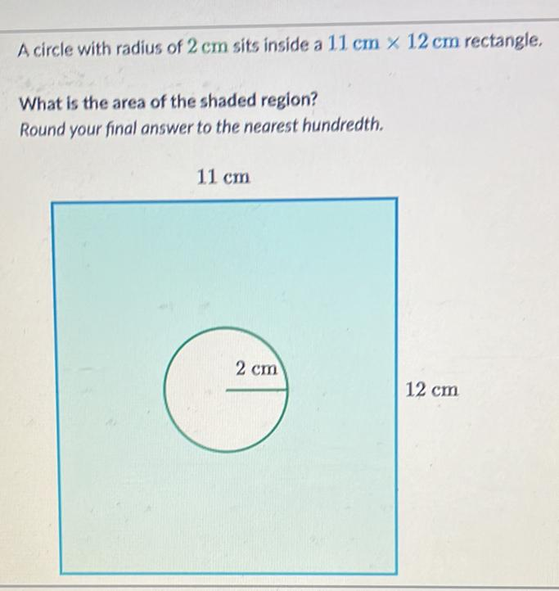
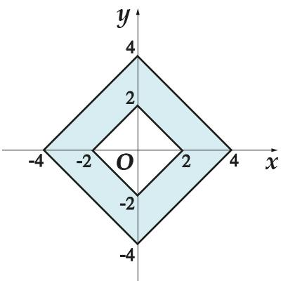
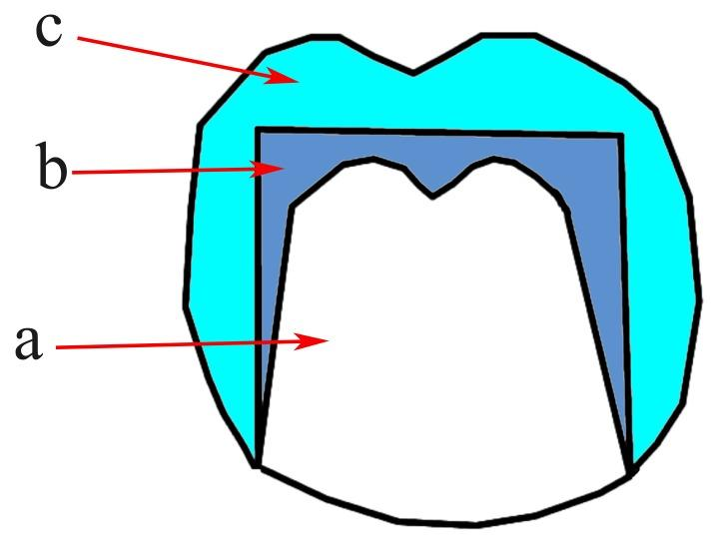
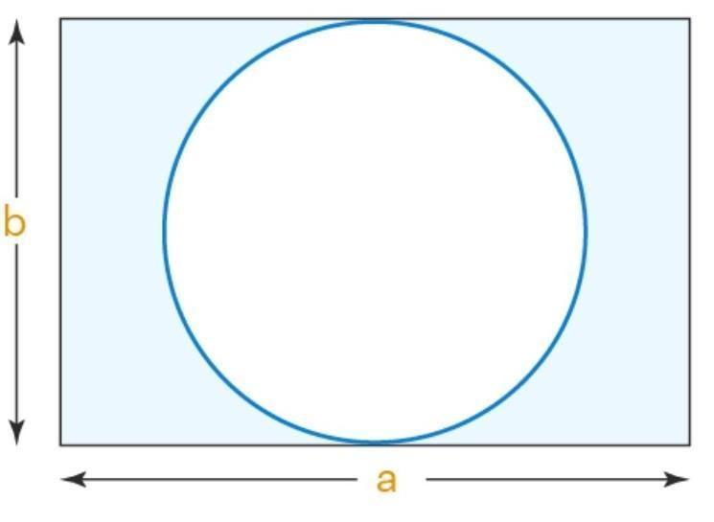

Purpose
# Source: AI Source: Provided by: [Data Path: Persons Table -> ID Column: 1, Name_En Column: Motasem Essam] -> From: [ChatGPT] on [7/25/2026]
Region containment describes the positional relationship between two regions.
It is used to determine whether:
- one region lies completely inside another;
- one region is a subset of another;
- two regions partially overlap;
- two regions are disjoint;
- the boundaries of regions are included or excluded.
It is fundamental in:
- Plane Geometry
- Topology
- Set Theory
- Coordinate Geometry
- Computational Geometry
- GIS
- CAD
- Computer Graphics

Fundamental Concept
# Source: AI Source: Provided by: [Data Path: Persons Table -> ID Column: 1, Name_En Column: Motasem Essam] -> From: [ChatGPT] on [7/25/2026]
A region is a set of points forming a specified area of a geometric space.
For example, a circular disk is a region:
$$R=\left\{\left(x , y\right)∣x^{2}+y^{2}≤r^{2}\right\}$$
If another region lies completely inside this disk, then it is contained in $R$.
For example:
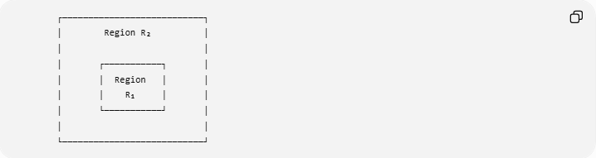
┌───────────────────────────┐
│ Region R₂ │
│ │
│ ┌───────────┐ │
│ │ Region │ │
│ │ R₁ │ │
│ └───────────┘ │
│ │
└───────────────────────────┘
Therefore:
$$\boxed{R_{1}⊂R_{2}}$$
Every point of $R_{1}$is also a point of $R_{2}$.

Mathematical Representation
# Source: AI Source: Provided by: [Data Path: Persons Table -> ID Column: 1, Name_En Column: Motasem Essam] -> From: [ChatGPT] on [7/25/2026]
Region containment is represented using subset notation:
$$\boxed{R_{1}⊆R_{2}}$$
or, for proper containment:
$$\boxed{R_{1}⊊R_{2}}$$
The pointwise definition is:
$$\boxed{R_{1}⊆R_{2} ⟺ ∀P \left(P∈R_{1}⇒P∈R_{2}\right)}$$
This is fundamentally a set-theoretic relationship.

Types of Region Containment
Region containment can occur in several forms.

1. Proper Region Containment
# Source: AI Source: Provided by: [Data Path: Persons Table -> ID Column: 1, Name_En Column: Motasem Essam] -> From: [ChatGPT] on [7/25/2026]
One region is completely inside another and the two regions are not equal:
$$\boxed{R_{1}⊊R_{2}}$$

2. Equal Region Containment
# Source: AI Source: Provided by: [Data Path: Persons Table -> ID Column: 1, Name_En Column: Motasem Essam] -> From: [ChatGPT] on [7/25/2026]
Two regions contain exactly the same points:
$$\boxed{R_{1}=R_{2}}$$
This is equality rather than proper containment.

3. Boundary-Touching Containment
# Source: AI Source: Provided by: [Data Path: Persons Table -> ID Column: 1, Name_En Column: Motasem Essam] -> From: [ChatGPT] on [7/25/2026]
A smaller region is contained within a larger region while its boundary touches the boundary of the larger region.
For example:
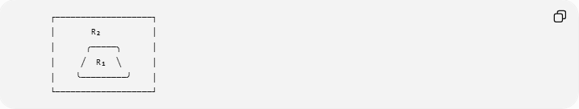
┌───────────────────┐
│ R₂ │
│ ╭─────╮ │
│ ╱ R₁ ╲ │
│ ╰─────────╯ │
└───────────────────┘
The smaller region remains contained if no point lies outside $R_{2}$.

4. Strict Interior Containment
# Source: AI Source: Provided by: [Data Path: Persons Table -> ID Column: 1, Name_En Column: Motasem Essam] -> From: [ChatGPT] on [7/25/2026]
The smaller region lies entirely inside the interior of the larger region:
$$\boxed{R_{1}⊂int⁡\left(R_{2}\right)}$$
This means that $R_{1}$does not touch the boundary of $R_{2}$.

Region Interior and Boundary
# Source: AI Source: Provided by: [Data Path: Persons Table -> ID Column: 1, Name_En Column: Motasem Essam] -> From: [ChatGPT] on [7/25/2026]
A region may be divided into:
- Interior
- Boundary
- Exterior
For a region $R$:
$$int⁡\left(R\right)$$
represents its interior, and:
$$∂R$$
represents its boundary.
A region can be contained in another region while its boundary either:
- remains completely inside;
- touches the outer boundary.
For strict interior containment:
$$\boxed{R_{1}⊂int⁡\left(R_{2}\right)}$$
For ordinary containment:
$$\boxed{R_{1}⊆R_{2}}$$

Example 1 — Circle Inside a Rectangle
# Source: AI Source: Provided by: [Data Path: Persons Table -> ID Column: 1, Name_En Column: Motasem Essam] -> From: [ChatGPT] on [7/25/2026]
Consider a rectangular region:
$$R_{2}=\left\{\left(x , y\right) , ∣0≤x≤10 0≤y≤8\right\}$$
and a circular region centered at:
$$\left(5 , 4\right)$$
with radius:
$$2$$
Then:
$$R_{1}=\left\{\left(x , y\right)∣{\left(x-5\right)}^{2}+{\left(y-4\right)}^{2}≤4\right\}$$
Every point of the circle lies inside the rectangle.
Therefore:
$$\boxed{R_{1}⊊R_{2}}$$

Example 2 — Smaller Circle Inside Larger Circle
# Source: AI Source: Provided by: [Data Path: Persons Table -> ID Column: 1, Name_En Column: Motasem Essam] -> From: [ChatGPT] on [7/25/2026]
Consider:
$$R_{1}:x^{2}+y^{2}≤4$$
and:
$$R_{2}:x^{2}+y^{2}≤25$$
The first region has radius $2$, while the second has radius $5$.
Since every point whose distance from the origin is at most $2$is also at most $5$:
$$\boxed{R_{1}⊊R_{2}}$$

Example 3 — Rectangle Inside Rectangle
# Source: AI Source: Provided by: [Data Path: Persons Table -> ID Column: 1, Name_En Column: Motasem Essam] -> From: [ChatGPT] on [7/25/2026]
Let:
$$R_{1}=\left\{\left(x , y\right) , ∣2≤x≤6 2≤y≤5\right\}$$
and:
$$R_{2}=\left\{\left(x , y\right) , ∣0≤x≤10 0≤y≤8\right\}$$
Every point of $R_{1}$belongs to $R_{2}$.
Therefore:
$$\boxed{R_{1}⊊R_{2}}$$

Region Containment in Coordinate Geometry
# Source: AI Source: Provided by: [Data Path: Persons Table -> ID Column: 1, Name_En Column: Motasem Essam] -> From: [ChatGPT] on [7/25/2026]
A region is frequently defined using inequalities.
For example:
$$R_{1}:x^{2}+y^{2}≤4$$
and:
$$R_{2}:x^{2}+y^{2}≤25$$
The inequalities allow us to compare the sets of points directly.
For more complicated regions, containment can be established by determining whether the defining inequalities of $R_{1}$imply those of $R_{2}$:
$$\boxed{P∈R_{1}⇒P∈R_{2}}$$

Region Containment and Set Theory
# Source: AI Source: Provided by: [Data Path: Persons Table -> ID Column: 1, Name_En Column: Motasem Essam] -> From: [ChatGPT] on [7/25/2026]
Region containment is essentially a geometric interpretation of the subset relation.
In set theory:
$$A⊆B$$
means every element of $A$belongs to $B$.
In geometry:
$$R_{1}⊆R_{2}$$
means every point of $R_{1}$belongs to $R_{2}$.
Thus:
$$\boxed{\text{Geometric containment}=\text{Set inclusion applied to geometric point sets}}$$

Transitivity of Region Containment
# Source: AI Source: Provided by: [Data Path: Persons Table -> ID Column: 1, Name_En Column: Motasem Essam] -> From: [ChatGPT] on [7/25/2026]
Containment is transitive.
If:
$$R_{1}⊆R_{2}$$
and:
$$R_{2}⊆R_{3}$$
then:
$$\boxed{R_{1}⊆R_{3}}$$
For example:
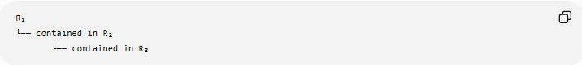
R₁
└── contained in R₂
└── contained in R₃
Therefore:
$$\boxed{R_{1}⊂R_{2}⊂R_{3}}$$
implies:
$$\boxed{R_{1}⊂R_{3}}$$

Region Containment and Point Containment
# Source: AI Source: Provided by: [Data Path: Persons Table -> ID Column: 1, Name_En Column: Motasem Essam] -> From: [ChatGPT] on [7/25/2026]
These concepts are directly related.
If:
$$P∈R_{1}$$
and:
$$R_{1}⊆R_{2}$$
then:
$$\boxed{P∈R_{2}}$$
Therefore:
$$\boxed{P∈R_{1}⊆R_{2}⇒P∈R_{2}}$$
This is another example of transitive containment.

Region Containment and Intersection
# Source: AI Source: Provided by: [Data Path: Persons Table -> ID Column: 1, Name_En Column: Motasem Essam] -> From: [ChatGPT] on [7/25/2026]
If:
$$R_{1}⊆R_{2}$$
then their intersection is the smaller region:
$$\boxed{R_{1}∩R_{2}=R_{1}}$$
This is an important distinction.
Containment
$$R_{1}⊆R_{2}$$
Intersection
$$R_{1}∩R_{2}$$
Containment tells us that one entire region lies inside another. Intersection identifies the points that the two regions have in common.

Region Containment vs. Overlap
# Source: AI Source: Provided by: [Data Path: Persons Table -> ID Column: 1, Name_En Column: Motasem Essam] -> From: [ChatGPT] on [7/25/2026]
These relationships should not be confused.
Containment
$$\boxed{R_{1}⊆R_{2}}$$
Every point of $R_{1}$belongs to $R_{2}$.
Partial Overlap
The regions share some points, but neither contains the other:
$$R_{1}∩R_{2}≠∅$$
while:
$$R_{1}⊈R_{2}$$
and:
$$R_{2}⊈R_{1}$$
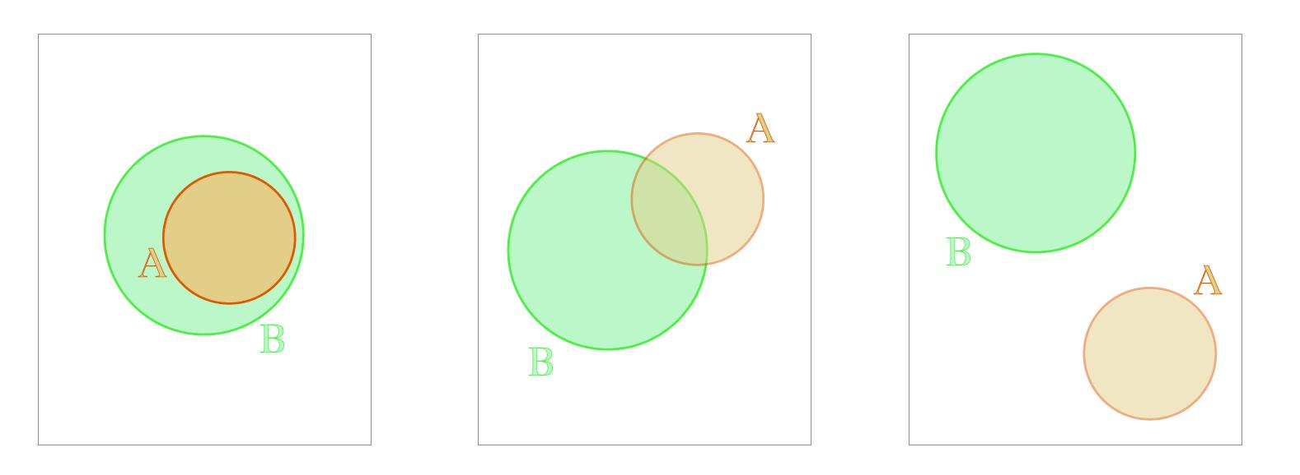
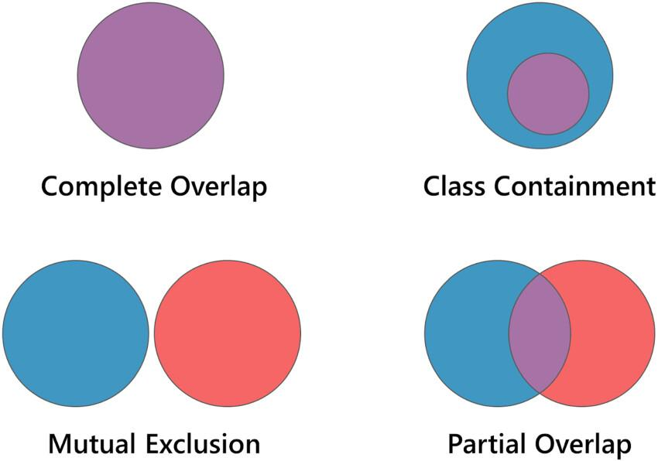
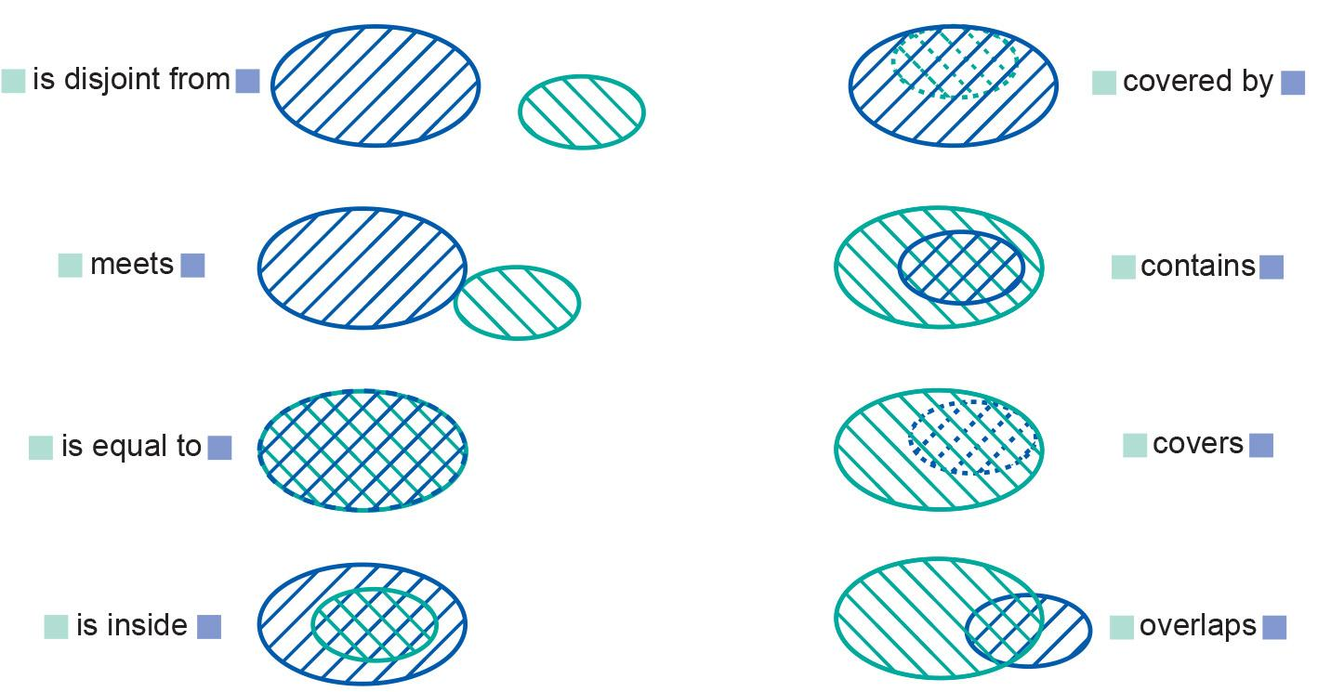

Region Containment vs. Disjointness
# Source: AI Source: Provided by: [Data Path: Persons Table -> ID Column: 1, Name_En Column: Motasem Essam] -> From: [ChatGPT] on [7/25/2026]
Two regions are disjoint if they have no common points:
$$\boxed{R_{1}∩R_{2}=∅}$$
If:
$$R_{1}⊆R_{2}$$
and $R_{1}$is nonempty, then the regions cannot be disjoint because:
$$R_{1}∩R_{2}=R_{1}$$

Region Containment vs. Coincidence
# Source: AI Source: Provided by: [Data Path: Persons Table -> ID Column: 1, Name_En Column: Motasem Essam] -> From: [ChatGPT] on [7/25/2026]
If:
$$R_{1}=R_{2}$$
the two regions coincide as sets.
This differs from proper containment:
$$R_{1}⊊R_{2}$$
Therefore:
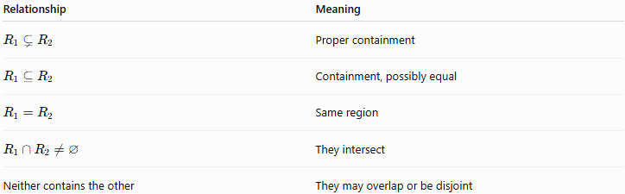
Relationship | Meaning
$$R_{1}⊊R_{2}$$ | Proper containment
$$R_{1}⊆R_{2}$$ | Containment, possibly equal
$$R_{1}=R_{2}$$ | Same region
$$R_{1}∩R_{2}≠∅$$ | They intersect
Neither contains the other | They may overlap or be disjoint

Closed and Open Regions
# Source: AI Source: Provided by: [Data Path: Persons Table -> ID Column: 1, Name_En Column: Motasem Essam] -> From: [ChatGPT] on [7/25/2026]
Boundary treatment is important when discussing regions.
A closed region includes its boundary.
For a circular disk:
$$\boxed{x^{2}+y^{2}≤r^{2}}$$
An open region excludes its boundary:
$$\boxed{x^{2}+y^{2}<r^{2}}$$
Therefore, containment can depend on whether boundaries are included.
For example, a region may satisfy:
$$R_{1}⊆R_{2}$$
but:
$$R_{1}⊄int⁡\left(R_{2}\right)$$
if $R_{1}$touches the boundary of $R_{2}$.

Strict Region Containment
# Source: AI Source: Provided by: [Data Path: Persons Table -> ID Column: 1, Name_En Column: Motasem Essam] -> From: [ChatGPT] on [7/25/2026]
Strict containment is useful when the smaller region must remain away from the boundary of the larger region.
$$\boxed{R_{1}⊂int⁡\left(R_{2}\right)}$$
This means:
- every point of $R_{1}$is inside $R_{2}$;
- no point of $R_{1}$lies on $∂R_{2}$.
This is stronger than ordinary containment.

Region Containment in Higher Dimensions
# Source: AI Source: Provided by: [Data Path: Persons Table -> ID Column: 1, Name_En Column: Motasem Essam] -> From: [ChatGPT] on [7/25/2026]
The concept is not limited to two-dimensional regions.
A region may exist in:
- a plane;
- three-dimensional space;
- higher-dimensional spaces.
For example, a 3D solid region $V_{1}$can be contained in another solid region $V_{2}$:
$$\boxed{V_{1}⊆V_{2}}$$
The same set-theoretic principle applies:
$$P∈V_{1}⇒P∈V_{2}$$
Thus, region containment is dimension-independent.

Region Containment in a Plane
# Source: AI Source: Provided by: [Data Path: Persons Table -> ID Column: 1, Name_En Column: Motasem Essam] -> From: [ChatGPT] on [7/25/2026]
If $R$is a planar region and $Π$is its containing plane:
$$\boxed{R⊆Π}$$
For example, a circular disk in the $xy$-plane satisfies:
$$R⊆\left\{\left(x , y , 0\right) , ∣xy∈R\right\}$$
Thus:
$$\boxed{\text{Region}⊂\text{Plane}⊂\text{Space}}$$

Region Containment in Space
# Source: AI Source: Provided by: [Data Path: Persons Table -> ID Column: 1, Name_En Column: Motasem Essam] -> From: [ChatGPT] on [7/25/2026]
If a planar region $R$lies in a plane $Π$, and:
$$Π⊂R^{3}$$
then:
$$\boxed{R⊂R^{3}}$$
This gives the chain:
$$\boxed{R⊂Π⊂R^{3}}$$

Important Properties
# Source: AI Source: Provided by: [Data Path: Persons Table -> ID Column: 1, Name_En Column: Motasem Essam] -> From: [ChatGPT] on [7/25/2026]
- Region containment is represented by:
$$\boxed{R_{1}⊆R_{2}}$$
- Every point of the contained region belongs to the containing region.
- Proper containment is:
$$\boxed{R_{1}⊊R_{2}}$$
- If $R_{1}⊆R_{2}$, then:
$$R_{1}∩R_{2}=R_{1}$$
- Containment is transitive.
- Equal regions are not properly contained:
$$R_{1}=R_{2}$$
- Partial overlap is not containment.
- Disjoint regions are not containment.
- Boundary inclusion matters for some region-containment problems.
- Region containment is fundamentally a set-inclusion relationship between geometric point sets.

Real-World Applications
# Source: AI Source: Provided by: [Data Path: Persons Table -> ID Column: 1, Name_En Column: Motasem Essam] -> From: [ChatGPT] on [7/25/2026]
1. Geographic Information Systems
A smaller administrative or geographic area can be contained within a larger geographic region.
2. Computer Graphics
A graphical object or clipping region can be tested for containment within another region.
3. CAD
Design regions can be checked to determine whether one face or profile lies completely inside another.
4. Architecture
Rooms, floor areas, and structural regions can be modeled as nested regions.
5. Robotics
A robot's reachable region can be analyzed relative to a larger permitted workspace.
6. Computational Geometry
Algorithms use region containment to determine:
- whether polygons lie inside other polygons;
- whether shapes are nested;
- whether objects are completely enclosed.

Comparison with Related Containment Types
# Source: AI Source: Provided by: [Data Path: Persons Table -> ID Column: 1, Name_En Column: Motasem Essam] -> From: [ChatGPT] on [7/25/2026]
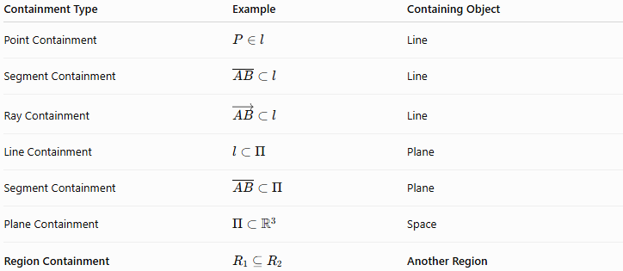
Containment Type | Example | Containing Object
Point Containment | $$P∈l$$ | Line
Segment Containment | $$\overset{‾}{AB}⊂l$$ | Line
Ray Containment | $$\vec{AB}⊂l$$ | Line
Line Containment | $$l⊂Π$$ | Plane
Segment Containment | $$\overset{‾}{AB}⊂Π$$ | Plane
Plane Containment | $$Π⊂R^{3}$$ | Space
Region Containment | $$R_{1}⊆R_{2}$$ | Another Region

Region Containment vs. Other Positional Relationships
# Source: AI Source: Provided by: [Data Path: Persons Table -> ID Column: 1, Name_En Column: Motasem Essam] -> From: [ChatGPT] on [7/25/2026]
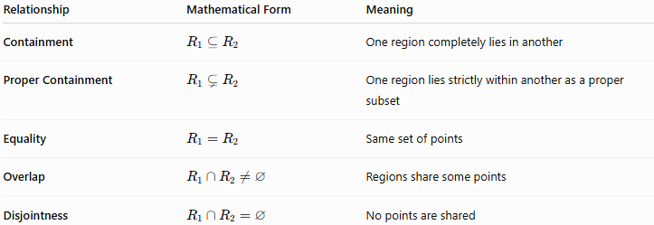
Relationship | Mathematical Form | Meaning
Containment | $$R_{1}⊆R_{2}$$ | One region completely lies in another
Proper Containment | $$R_{1}⊊R_{2}$$ | One region lies strictly within another as a proper subset
Equality | $$R_{1}=R_{2}$$ | Same set of points
Overlap | $$R_{1}∩R_{2}≠∅$$ | Regions share some points
Disjointness | $$R_{1}∩R_{2}=∅$$ | No points are shared

Containment Hierarchy
# Source: AI Source: Provided by: [Data Path: Persons Table -> ID Column: 1, Name_En Column: Motasem Essam] -> From: [ChatGPT] on [7/25/2026]
Region containment introduces a new branch in the hierarchy because the containing object is itself a region.
A useful general chain is:
$$\boxed{\text{Point}⊂\text{Segment}⊂\text{Line}⊂\text{Plane}⊂\text{Space}}$$
while regions can occur at different dimensions:
$$\boxed{\text{Region}⊂\text{Plane}⊂\text{Space}}$$
and:
$$\boxed{{\text{Region}}_{1}⊂{\text{Region}}_{2}}$$
describes containment between regions.

Key Points
# Source: AI Source: Provided by: [Data Path: Persons Table -> ID Column: 1, Name_En Column: Motasem Essam] -> From: [ChatGPT] on [7/25/2026]
- Region Containment means one geometric region lies completely within another.
- Its fundamental notation is:
$$\boxed{R_{1}⊆R_{2}}$$
- Proper containment is:
$$\boxed{R_{1}⊊R_{2}}$$
- Every point of $R_{1}$belongs to $R_{2}$.
- Region containment is essentially set inclusion applied to geometric regions.
- If $R_{1}⊆R_{2}$, then:
$$R_{1}∩R_{2}=R_{1}$$
- Partial overlap is not containment.
- Disjointness is not containment.
- Boundary inclusion can distinguish ordinary containment from strict interior containment.
- Region containment can occur in two, three, or higher dimensions.

Conclusion
# Source: AI Source: Provided by: [Data Path: Persons Table -> ID Column: 1, Name_En Column: Motasem Essam] -> From: [ChatGPT] on [7/25/2026]
Region Containment describes the complete inclusion of one geometric region within another:
$$\boxed{R_{1}⊆R_{2}}$$
The defining principle is:
$$\boxed{P∈R_{1}⇒P∈R_{2}}$$
for every point $P$in the contained region.
It is therefore a fundamental set-theoretic and geometric positional relationship, connecting point containment, region interiors and boundaries, intersection, overlap, and higher-dimensional containment.
For your taxonomy, the cleanest placement is:
$$\boxed{\text{Geometric Relationships}→\text{Positional Relationships}→\text{Containment}→\text{Geometric Object Containment}→\text{Region Containment}}$$

